Crumb Clean Commitment
NEVER FEED WILDLIFE
HOW?
- Never leave food, coolers, or trash unattended, including pet food, paper plates, bags and wrappers, or candles.
- Store all food and smelly items in your car or in the metal food lockers even if you are away for only a short time.
- Properly dispose of all trash, even crumbs, bacon grease, and other food scraps. The fire ring or the bushes are not proper places to dispose of trash.
WHY?
- This park is home to the Marbled Murrelets, an endangered sea bird that needs these big trees to nest.
- Ravens and Jays eat Marbled Murrelet eggs and chicks.
- Human food left by park visitors causes a huge increase in the number of Ravens and Jays threatening the survival of Marbled Murrelets.
- Feeding wildlife or leaving food or trash unattended is against the law and can result in fines of up to $875.00.
(CCR T-14 4305 and 4323)
- If we don’t reduce the numbers of Jays and Ravens through being crumb clean, State Parks might have to close down the campgrounds to protect the Marbled Murrelet.

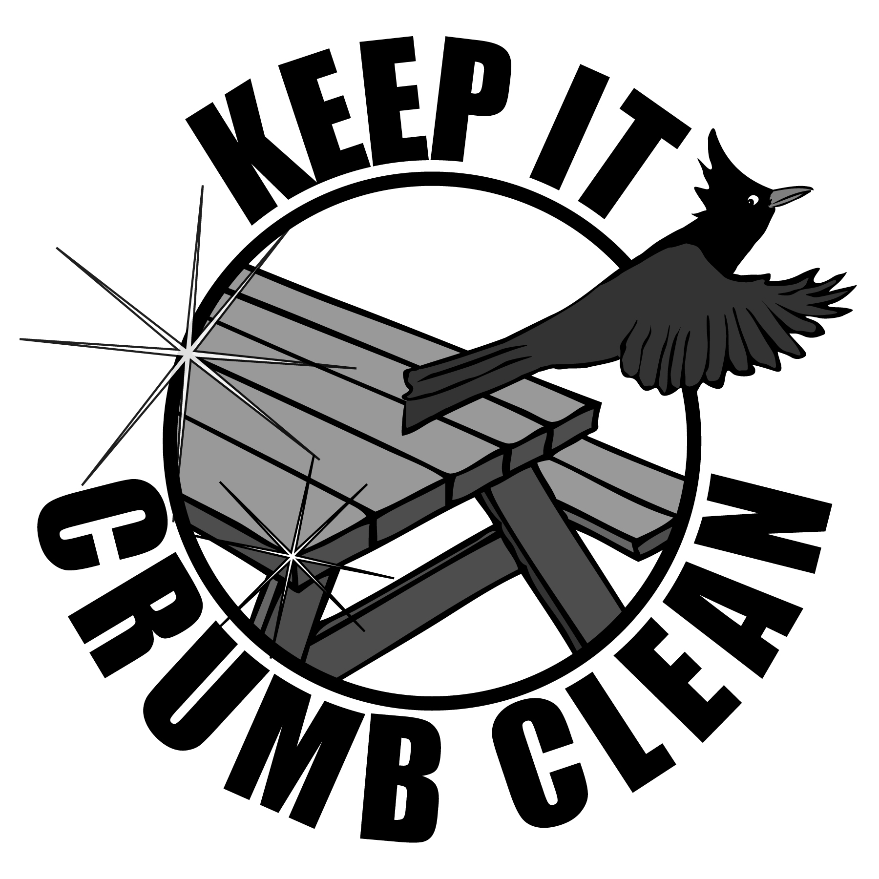
By signing this commitment, I am acknowledging that I have read and understand the rules regarding food storage and I will keep it Crumb Clean!

______________________________________
Signature
Crumb Clean Commitment
NEVER FEED WILDLIFE
HOW?
- Never leave food, coolers, or trash unattended, including pet food, paper plates, bags and wrappers, or candles.
- Store all food and smelly items in your car or in the metal food lockers even if you are away for only a short time.
- Properly dispose of all trash, even crumbs, bacon grease, and other food scraps. The fire ring or the bushes are not proper places to dispose of trash.
WHY?
- This park is home to the Marbled Murrelets, an endangered sea bird that needs these big trees to nest.
- Ravens and Jays eat Marbled Murrelet eggs and chicks.
- Human food left by park visitors causes a huge increase in the number of Ravens and Jays threatening the survival of Marbled Murrelets.
- Feeding wildlife or leaving food or trash unattended is against the law and can result in fines of up to $875.00.
(CCR T-14 4305 and 4323)
- If we don’t reduce the numbers of Jays and Ravens through being crumb clean, State Parks might have to close down the campgrounds to protect the Marbled Murrelet.

By signing this commitment, I am acknowledging that I have read and understand the rules regarding food storage and I will keep it Crumb Clean!

______________________________________
Signature
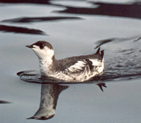
So just what is a Marbled Murrelet?
Marbled Murrelets are sea birds that live along the Pacific Coast from central California to Alaska and nest in old growth forests.
Adult Marbled Murrelet at Sea
Their nesting habits were the last of any bird in North America to be discovered. In 1974, a tree trimmer cleaning storm damage in Big Basin Redwoods State Park found a Marbled Murrelet chick 150 feet up in a tree on a mossy branch, solving the mystery.
Adult Marbled Murrelet at Sea
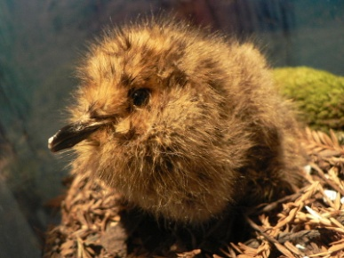
Now we know that parents lay a single egg high up on the branches of old growth trees. They take turns incubating the egg and flying miles to the ocean to eat and, after the chick hatches, catch fish to bring back to feed their baby. About 30 to 40 days after hatching, the young Marbled Murrelet takes its first flight and goes all the way to the ocean.
Marbled Murrelet chick

Marbled Murrelets are now endangered because so much of the old growth forests they need to raise their young have been cut down The old growth forest that’s left is often in parks where the presence of people and their food has attracted huge numbers of Jays and Ravens which eat Marbled Murrelet eggs and chicks.
By being Crumb Clean we can restore balance to the forest and we can save this bird that connects the trees to the seas!

So just what is a Marbled Murrelet?
Marbled Murrelets are sea birds that live along the Pacific Coast from central California to Alaska and nest in old growth forests.
Their nesting habits were the last of any bird in North America to be discovered. In 1974, a tree trimmer cleaning storm damage in Big Basin Redwoods State Park found a Marbled Murrelet chick 150 feet up in a tree on a mossy branch, solving the mystery.
Now we know that parents lay a single egg high up on the branches of old growth trees. They take turns incubating the egg and flying miles to the ocean to eat and, after the chick hatches, catch fish to bring back to feed their baby. About 30 to 40 days after hatching, the young Marbled Murrelet takes its first flight and goes all the way to the ocean.
Marbled Murrelet Chick

Marbled Murrelets are now endangered because so much of the old growth forests they need to raise their young have been cut down. The old growth forest that’s left is often in parks where the presence of people and their food has attracted huge numbers of Jays and Ravens which eat Marbled Murrelet eggs and chicks.
By being Crumb Clean we can restore balance to the forest and we can save this bird that connects the trees to the seas!

